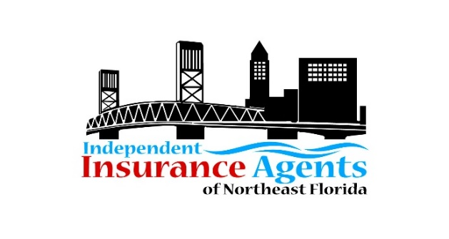
2021 MEMBERSHIP APPLICATION AND RENEWAL FORM
ANNUAL DUES ARE PAYABLE IN JANUARY 2021

Agency/Company Name: _____________________________________________
Local Mailing Address:________________________________________________
City, State, and Zip: __________________________________________________
Agency Principal or Company Representative: _____________________________
___________________________________________________________________
Email: _____________________________________________________________
Phone: ___________________________________________________________
Website/LinkedIn/Facebook group pages:_________________________________ ___________________________________________________________________
Anyone else you want to receive IIANF information, updates, reminders, etc? ___________________________________________________________________
Email(s): ___________________________________________________________
Number of Employees in your office: ___________
Please complete this form and send it with annual dues payment to IIANF, P.O. Box 24570, Jacksonville FL 32241 by January 30, 2021. Make check payable to IIANF.
You may email this completed form to margy@iianf.com. Please provide your company logo by emailing to margy@iianf.com Questions? Call IIANF at 904-460-9577 or email.

Thank you for your membership!

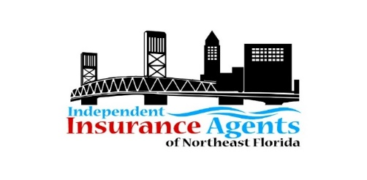2021 MEMBERSHIP DUES
Agency Membership: Dues are based on annual written premiums. Note, dues have not increased in the past seven years! Membership includes access to Lunch and Learn Series, Quarterly Meetings, Networking Events, Charitable Events, and Continuing Education Classes, and Big “I” Day registration discounts.

Associate Membership: New in 2021, Associate Members receive a complimentary Big “I” Day sponsorship (see list below to choose your preference.) Note, dues have not increased in three years!

Legislative: The IIANF participates in local and state legislative initiatives and provides an updated list of critical issues relevant to the insurance industry and independent agents.

Education and Training: IIANF supports workforce development training, mentorship, and scholarships and offers various educational training for its members and associates.
AGENCY DUES
Dues based on Agency’s Annual Written Premiums | ANNUAL DUES | EDUCATION  (OPTIONAL) | LEGISLATIVE (OPTIONAL) | TOTAL DUE  Apply $50 discount if paid by 01/15/2021
$15,000,000-$25,000,000+ | $800.00 | $100 | $75 | $975.00
$10,000,000-14,999,999 | $700.00 | $100 | $75 | $875.00
$5,000,000-$9,999,999 | $625.00 | $100 | $75 | $800.00
$1,000,000-$4,999,999 | $550.00 | $100 | $75 | $725.00

ASSOCIATE MEMBER DUES
ANNUAL DUES | EDUCATION (OPTIONAL) | LEGISLATIVE (OPTIONAL) | TOTAL DUE  Apply $50 discount if paid by 01/15/2021
$450 | $100 | $100 | $625.00
Associate Member Dues include a Big “I” Day sponsorship. Please check your preference.
Big “I” Day Sponsorship Opportunities
Additional opportunities are available. Contact IIANF for details.
Golf Hole Sponsorship ($300 value)
Casino Table Sponsorship ($400 value)
Hole-in-One Coverage/Prizes (2 available; $400 value)
Proximity Contests and Prizes ($400 value)

Have questions?
Contact IIANF at margy@iianf.com or
904-460-9577.

Please mail your check, made payable to IIANF, to IIANF, P.O. Box 24570, Jacksonville FL 32241. Remember to take advantage of the $50 discount by paying dues by January 15, 2021. Thank you!

